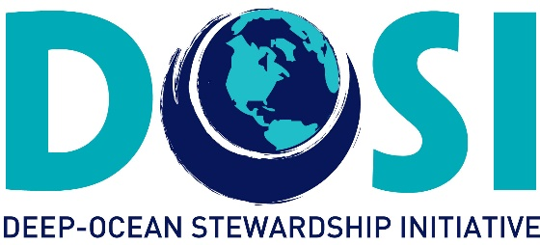

Report on the EREGS Workshop
A workshop to discuss elements of the ISA Discussion Paper on the development and drafting of Regulations on Exploitation for Mineral Resources in the Area (Environmental Matters)

1-3 February 2017, Scripps Institution of Oceanography, La Jolla, California
Workshop Co-Leads: Lisa Levin & Verena Tunnicliffe

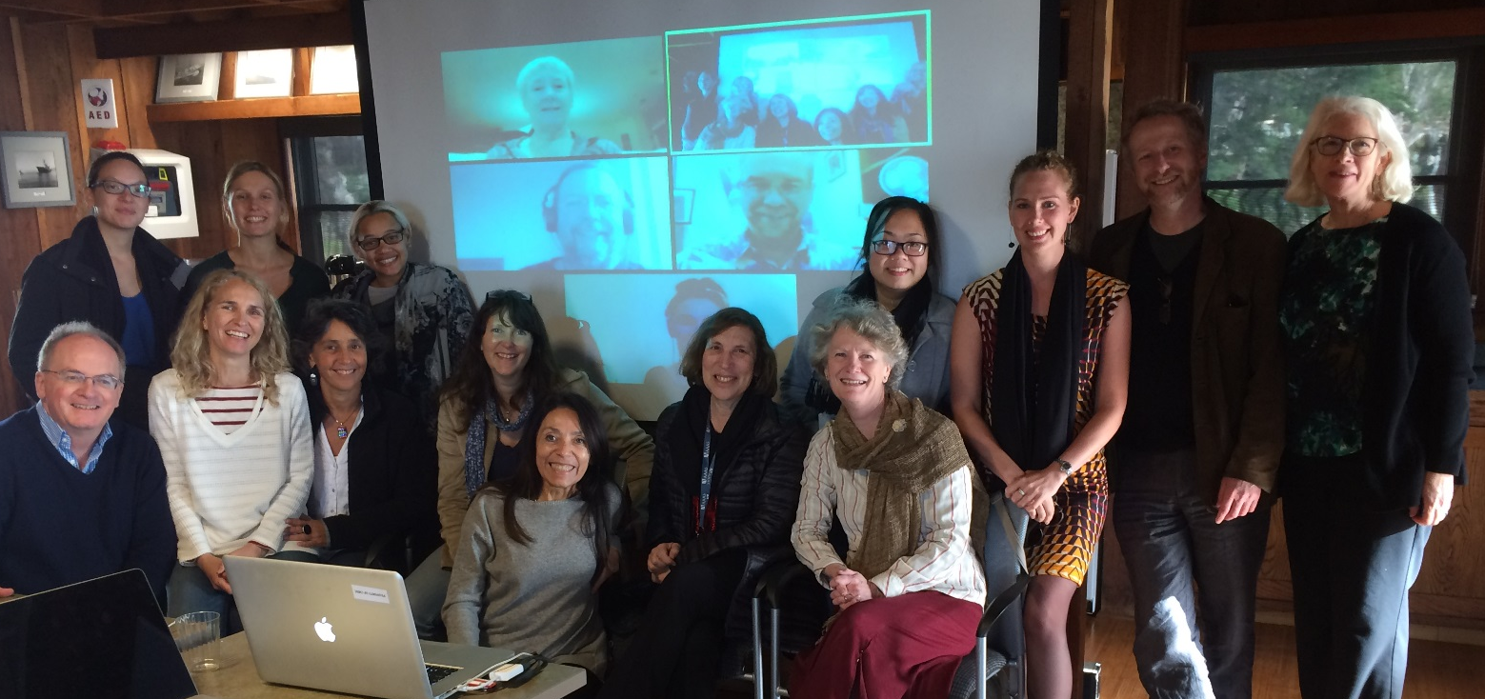

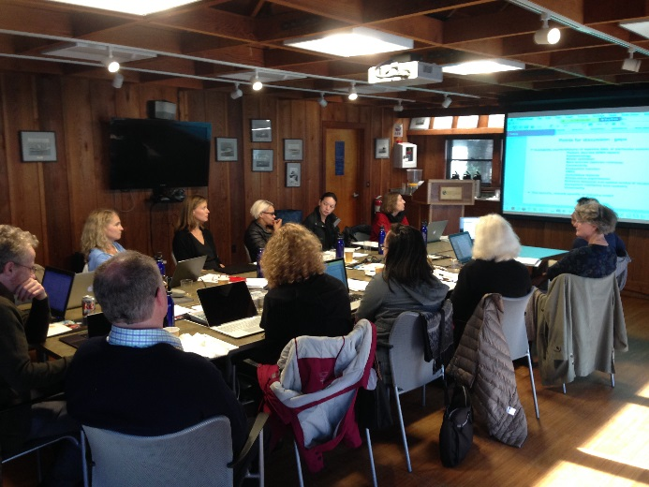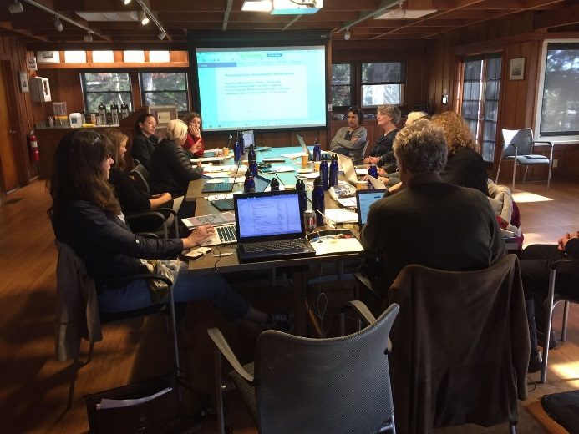

WORKSHOP OBJECTIVES

The overall objective of this DOSI workshop was to evaluate and review the ISA discussion paper for environmental elements of the exploitation regulations from a (predominantly) scientific perspective. DOSI has made comments on all previous stakeholder engagement calls from the ISA in terms of their exploitation regulations and for these latest regulations focussing on environmental matters we plan to be in a good position to provide a comprehensive response when called for. The ISA has a huge and difficult task ahead and the DOSI Minerals WG members hope to help, alongside others, towards ensuring significant (and crucial) scientific expert input at an early stage.

This workshop brought together 20 DOSI experts from a variety of disciplines and countries to deliberate on key aspects of the regulations. Here we provide a summary of the workshop. A more detailed report can be made available upon request.

In advance of the workshop, each participant was required to review assembled documents that allowed us to assess positions, precedents, research and current thoughts on seabed mining. Small groups of participants considered over 40 documents and presented distillations to the Workshop.

At the outset, our specific workshop aims were to:

- Define scientific principles, concepts and information that must underlie the different elements of exploitation environmental regulations including SEA, baseline studies, impact assessment and monitoring.
- Identify specific scientific issues that must be addressed within exploitation environmental regulations, and recommend approaches.
- Advise on scientific criteria and technologies for specific regulatory protocols, decision-making processes.
- Highlight scientific knowledge gaps relevant to environmental regulation of exploitation mining, ways to fill these and ways forward under uncertainty and the absence of information.
- Discuss applicability of environmental regulations across resource types, scientific differences that may require resource-specific adaptation, and ways to incorporate this flexibility into ISA wording and regulations.
- Develop a preliminary response to the issued Draft and a protocol for formulating a full response.

On day 1, presentations and discussions around key relevant literature were made. These included:

I. Assessment of the Griffith/ISA Workshop report (2016)
We reviewed history, objectives & participants and identified key aspects needing further work (standard definitions and terms, functional definitions for “adverse impact” and “vulnerable marine ecosystems”, thresholds, limits and triggers, priorities for effective environmental management, practical use of and access to environmental data, inclusion of ecosystem function in environmental assessment).

II. Status and Outcomes from emerging programmes studying deep-sea mining environmental issues
Salient points were summarised from MIDAS, NZ Shelf Act, CCZ research findings, and previous ISA studies. These included the need for rigorous science (including ecosystem function, resilience, recover and connectivity) in setting thresholds and to determine effective set-aside areas, consideration of biochemical processes in impacts, need to determine role of VMEs, importance of Regional Strategies, limitations of plume models (including their unknown effects on biota) and current ecotoxicology assessments. CCZ research suggests nodule fauna is highly diverse with many rare species (and poorly-known) and hence long-term habitat loss can prevent recovery from mining.

GAPS of important note (relative to science) include:
- Clearly defined thresholds of impact
- Clearly articulated targets for conservation (including APEIs)
- Guidelines for monitoring (metrics, timeline, reference sites, endpoints)
- Triggers for work-stop
- How to select, designate & manage MPAs in the Area
- Science standards for assessing and reporting uncertainty
- Role of science in Adaptive Management
- Availability (current/future) of baseline data. Of particular concern are: Plumes, ecotoxicology, model validation, rare species, connectivity, ecosystem function, VMEs, cumulative impacts, manipulative experiments, relevant temporal and spatial scales of impact, ecosystem resilience and recovery and uncertainty.

III. Stakeholder Comments on Draft Exploitation Regulations (Env/Science)
For this exercise we created a spreadsheet from the comments available on the ISA website and distilled relevant and/or frequently made comments around science-informed issues. Some examples of subjects covered are definitions, serious harm, adaptive management, scientific research, applications, plans of work expert review and data. Further information on the details are available upon request.

IV. Some Guiding Concepts
The group worked on pulling together summary information on some guiding concepts including on the common heritage of mankind, transparency, the precautionary approach, adaptive management and serious harm – all of which are available upon request.

DISCUSSION SUMMARIES

During the workshop, days 2 and 3, we met in Plenary and Breakout groups to discuss specific topics. We did address some sections of the Discussion Paper but did not attempt to cover it all. The main topics under discussion were:

A. FIRST RESPONSE TO DOCUMENT (Plenary)
Overall: The ‘Discussion Paper’ is tentative and needs significant development, however the overall impression and direction was positive. Implications for changes to overall ISA strategy and organization structure are notable. Excellent steps towards greater transparency. Contained within are very difficult issues but the document gives a good starting point so kudos to the writer. We noted very positively the inclusion of information from previous consultations. There was a recognised need for strategic workshops on some elements (e.g. operationalizing definitions, resolving concept of Serious Harm). Clarity of responsibilities is required. We noted a lack of emphasis on the Common Heritage of Mankind (CHM), and the concept of mining for benefit of mankind.
Outcome: We developed a list of positive features, and identified major ‘next steps’.

B. VULNERABLE MARINE ECOSYSTEMS (Plenary)
Overall: How is the VME concept applied in terms of mining? The FAO approach does not seem feasible due to the destructive nature of mining. Need to build on SEMPIA discussions of VMEs. .
Outcome: An additional workshop planned to move forward on hydrothermal vent ecosystems in the VME context (Van Dover to lead).

C. DEFINITIONS (Plenary)
Overall: The group feels that most definitions need work and identified some that are missing.
Outcome: DOSI is creating an on-line venue to post/discuss revised definitions. We have selected several key terms for priority attention: Acceptable, Benthic Plume, Environmental Baseline, Environmental Impact, Environmental Target, Impact Reference Zone.

D. AIMS OF THE Environmental Regulations Discussion Document (EREGS) (Breakout)
Overall: Very interesting document signalling a shift in approach for the Authority that includes good public consultation and involvement of experts. Some terminology needs definition.
Outcomes: i) Flow chart of process inferred from the document; and. ii) wording suggestions for Aims (p.6 of Draft).

Draft flowchart of environmental application process in the tentative draft regulations
The flowchart (page 5) is our interpretation of how the process will flow based on reading the current document. Colour Coding in the flowchart reflects: i) Who is involved in the process and ii) Whether expert/external review is involved.

E. THE ENVIRONMENTAL BASELINE (Breakout)
Overall: A breakout group discussed how the document uses or comments on the Environmental Baseline that is required by the Exploration Regulations. Time was limiting so a few points were pulled.
Outcomes: A detailed list was drawn up with our recommendations and included, for example:
ISA should develop a separate guidance document on the Roles and responsibilities of Sponsoring States reflecting the ITLOS AO; Environmental Regulations should cover all deposit types, with Guidelines/Recommendations/Annexes to provide deposit-specific guidance as necessary, as these may require more frequent amendment. However, contracts should have mandatory requirements that adherence to the Guidelines/ Recommendations and any updates is complied with. Environmental Regulations should reference and align with Strategic Environmental Management Plans and strategies; Level of uncertainty needs to be included in EIS, ie verification of modelling; Data management system needs to ensure that all data collected by contractors is reported to the Authority 3 years post cruise and open reporting of all environmental data; Workshops on data standardisation and to train contractors on sampling methodology should be encouraged and continued and extend to an ‘at-sea’ practical workshop; Best practice updates need to be made available to contractors on the ISA website in a way that is accessible to Contractors.

F. ENVIRONMENTAL GOALS (Breakout)
Overall: We found that it was not possible to assess how science can inform data collection, assessment, and environmental review without understanding the overall Environmental Goals for environmental management of mining in the deep sea. These goals were referred to in the Discucssion Paper, but no goals or objectives were stated. Thus, we discussed what those goals and objectives should be.
Outcomes: A set of potential Goals were identified, drawing on the LoS, FAO, and ISA precedents. These are summarized as: To preserve CHM for future generations, including biological, geological and cultural resources and services; Ensure that development of DSM is done in the context of sustainable development; Protect and preserve the marine environment through the application of precautionary approach; Sustain marine benthic and pelagic ecosystem integrity, including the physical chemical, geological and biological environment; Generate and share best scientific information available for decisions-making and improve techniques for dealing with risk and uncertainty; Ensure ecosystem integrity on regional scales by integrating strategic and contractor environmental management plans.

- Initial submission
- Secretariat-led review
- Revised submission
Appeal procedures may also be specified as a 7th stage. Both appeals by Contractors / Sponsoring States and appeals by the public and/or Interested Persons would need to be considered.
- Final decision
- LTC-led review
Is the assessment of baseline info to happen prior to assessment of the rest of the submitted package? Or, can it happen concurrently? (Each approach has pros and cons.) Also, is the baseline info subject to external review (by experts/Interested Persons)?
Reg 36 seems to suggest that all Env. Plans are subject to review by Interested Persons. Presumably that includes the Risk Assessment and Emergency Plan, not only those documents specifically listed in Regs 26(3), 29(3), and 32(4) as being subject to review.
Commentary: It is unclear whether the risk assessment is received together with the full application or prior to it. In any case, it appears the review stage is for the entire package.
- Scoping
(currently optional)
G. GUIDING PRINCIPLES (Breakout)
Overall: We examined the Discussion Paper’s Preamble and the Guiding Principles (Part II, Section 2, p25) with the objective to understand that basis for the document and to assess whether any gaps existed.
Outcomes: Recommended edits and inclusions were suggested. Some key components include: that the Preamble should include an objective to ensure a transparent decision-making process; that the Preamble should include an objective to consider the common heritage of humankind by not foreclosing on options for future generations; that the term “ecological balance” be defined; that reference to Precautionary Approach use the wording in the Advisory Opinion, and that application to only Serious Harm situations be reconsidered (it needs application at a lower threshold).

H. ENVIRONMENTAL IMPACT ASSESSMENT (Breakout)
Overall: The group discussed the structure and elements of the EIA including the scoping report. Subsequently a brief plenary discussion on the EIS (Reg 32) occurred.
Outcomes: Several points were made and included:The Scoping Report should be mandatory to help Contractor and Authority to identify issues early; Include expert review at the scoping stage; Consider an entry for the Scoping Report to include Common Heritage of Humankind; Need to define thresholds for impacts; Current comments in Reg 18 only give the example of plumes to determine the Environmental Impact Area but there are other processes that are important e.g connectivity and source populations, nursery areas, migration routes, noise, trophic interactions; Ecosystem function should be included in the baseline and EIA.

I. SERIOUS HARM (Breakout and Plenary)
Overall: We acknowledged that an operational definition of serious harm must underly many aspects of the Environmental Regulations. We thus discussed definition and operationalization of serious harm.
Outcomes: Issues raised include: A common definition of serious harm continued to elude us, however, we agreed that seabed mining causes serious harm to the local ecosystems; We were divided on whether we should be defining what is ‘acceptable’ harm or whether we just stick to clarifying the nature of likely serious harms at varying scales; Many agreed that serious harm could only be operationalized in the context of the environmental regulations if it is considered within a hierarchy of spatial and temporal scales of impact; Time scales by which to consider ecological harm and possible recovery must also be selected, with consideration to both ecological and regulatory relevance; The Discussion Paper’s definition (p10) should be expanded to include more aspects of the marine ecosystems affected; Cost-benefit analysis of serious harm: many felt that the burden of proof should be on the Authority and its 168 State parties to demonstrate the reasonable trade-offs involved in mining; Serious harm should be evaluated against the environmental objectives and targets of the Authority; We discussed the merits of a ‘deep ocean health index’ based on an overarching environmental objective to maintain ecosystem integrity, including structures, functions and services; such an index is in operation in several States; Possible recommendation were discussed around operationalizing assessment of serious harm; There are many indicators of serious harm: we discussed the feasibility of some of these but a workshop focussed on the topic would be a logical next step.

WORKSHOP PRODUCTS PLANNED OR UNDERWAY
- Full report to capture essence of meeting: to include homework summaries, discussion summaries and overall impressions.
- A briefer report to ISA by Feb 18 with our overview
- Report to funders (HEREWITH)
- A statement of response prepared for the Berlin (Mar 20) meeting.
- A draft of some critical Definitions.
- Plan for a hot vent VME meeting in May

Participant List

Aline Jaeckel | Macquarie Law School | Australia
Alison Swaddling | University of Sydney (prev. SPC-EU Project, Fiji) | Australia
Amber Cobley | University of Southampton | UK
Andrey Gebruk | P. P. Shirshov Institute ofOceanology | Russia
Anna Metaxas | Dalhousie University | Canada
Cindy Van Dover | Duke University | USA
Craig Smith | University of Hawaii | USA
David Billett | Deep Seas Envionmental Solutions Ltd | UK
Elva Escobar | Instituto de Ciencias del Mar y Limnología, UNAM | Mexico
Eva Ramirez-Llodra | Norwegian Institute for Water Research (NIVA) | Norway
Jeff Ardron | Commonwealth Secretariat | UK
Jen Le | Scripps Institution of Oceanography | USA
Kristina Gjerde | IUCN | USA
Lisa Levin | Scripps Institution of Oceanography | USA
Maria Baker | University of Southampton | UK
Matthew Gianni | Deep Sea Conservation Coalition | The Netherlands
Megan Jungwiwattanaporn | PEW Charitable Trusts | USA
Prideel Majiedt | South African National Biodiversity Institute | SA
Rachel Boschen | University of Victoria | Canada
Verena Tunnicliffe | University of Victoria | Canada

