ONE OPORTUNITY OF LEARNING AND CROSSING BORDERS
By: Ana Karina Luna Cruz
When I was notified that had been selected to receive one of the five prizes awarded by the Deep Ocean Stewardship Initiative with the Endowment Fund of the International Seabed Authority to attend the 15th DSBS and the DOSI day on the past 9th of September, I could not believe it!, I had to read the email a second time. So it took me a short time, before I could recognize that it was a great opportunity for me. In the following weeks, I started planning everything for that trip.
I was very excited about the idea of being able to present part of the research that I had been doing for a year and half as a master student at Universidad Nacional Autónoma de México. It would be the first time that I would attend an event of this size, with a wide range of topics. Also, that would be the first time that I would travel outside of Mexico.
My stay during the symposium resulted in a great academic, cultural and personal learning. The opportunity to meet and interact with scientist from others parts of the world from who I had been following their recent career in deep ocean research, was very rewarding for me. I had read their papers, and listen to them in their plenaries was like receiving a direct class from someone who had indirectly motivated the emergence of new scientific questions throughout the course of my project. My enthusiasm was not only motivated by meet and listen to them, but also by see how they do with true dedication and passionately convey their work.
Most of the trips that a person can make outside of his home town are already a sea of cultural knowledge, which becomes even greater with the dialogue with other people. I met and spoke with other attendees from different regions of the world with interests similar to mine, some of them very young and with great enthusiasm for have ventured into this career, which was resulting in a great and amazing learning to me. Now I have some friends in different regions of the United States, Japan, Argentina and Brazil! In the near future we will probably coincide again and we will remember with gratitude the moment in which we met.
One of the moments that I really enjoyed during the symposium, was when three young researchers were invited to give a brief overview of their career, they shared with us their successes but also the challenges presented to them. What was motivating to me was to know how they grew in their professional career overcoming difficulties and limitations.
Another event that I like the most was when Steven Haddock, at the end of his extraordinary talk in bioluminescence, let us all know that the motivation of his work and personal support of what had involved summoning a large number of scientists had been his family, then I thought that the achievements of a scientist’ work is not came only of himself or his team, there are other people behind all that effort accompany us and share with us the satisfaction.
On the other hand, the DOSI meeting impressed me. Previously I had not had the opportunity to participate in a real manner to implement everything we know about the ecological challenges in the world that we are facing.
There is currently a thought in some science groups that the roll of scientists is based on finding a phenomenon, questioning this, try to explain it, understand and generate information. But how far can all the information we generate have impact? I think the true scope happens until collectively we manage to execute the solutions to a problem. Attending the DOSI day made me know there is a part of science community working in a positive change with ecological problems in the ocean that we are currently facing. The scientists not only write papers to generate information; options and possible answers are being proposed and now the work of the science goes committed beyond laboratory tests.
Mexico is not a country that has opted to invest widely in scientific research; the opportunities and financial support that we can have access are limited. However, I think we are working hard and can confront the difficulties to develop high quality work. Receiving the award from ISA and DOSI was not only an opportunity to present part of my research in an international scientific meeting, now I see it as a reward of the hours of work and effort invested, and the motivation to believe that there is long way in front of me.
Have this experience made me recognize two personal things: 1.- I have given the first step to start in what will be a long and arduous career, but very rewarding; 2.- in the future, I would like to become the person that motivates generations of younger scientist. Finally it represented the achievement of an academic challenge and a personal one.

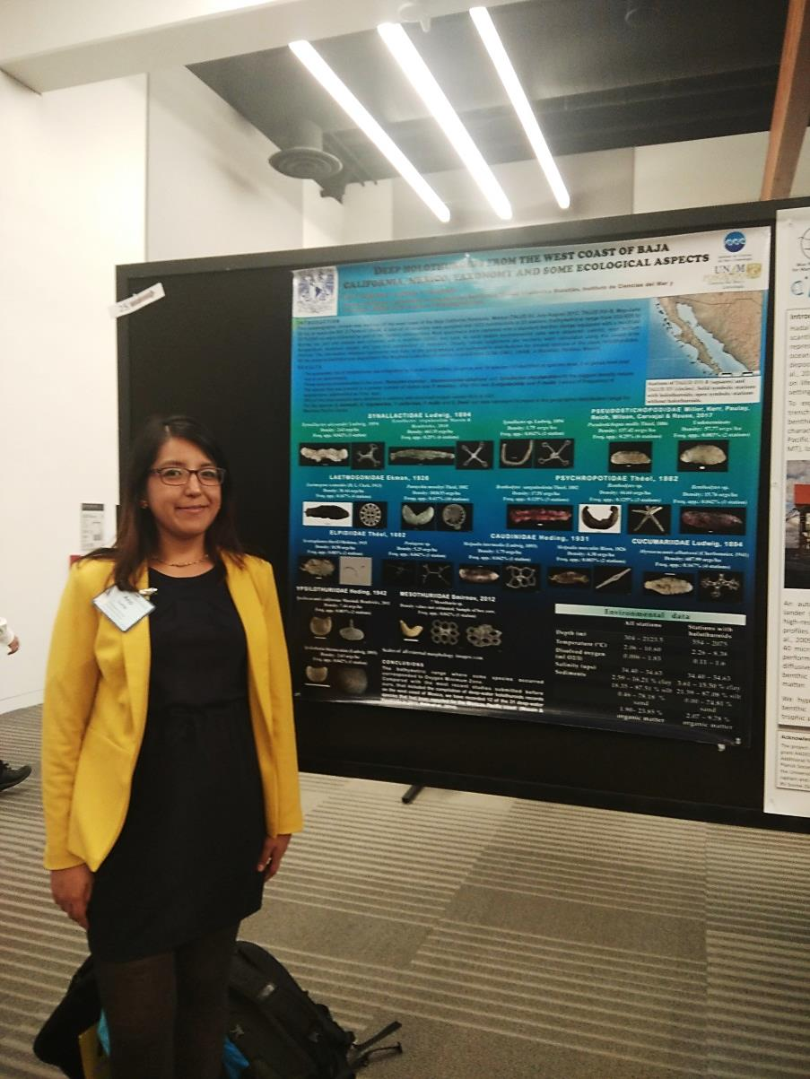
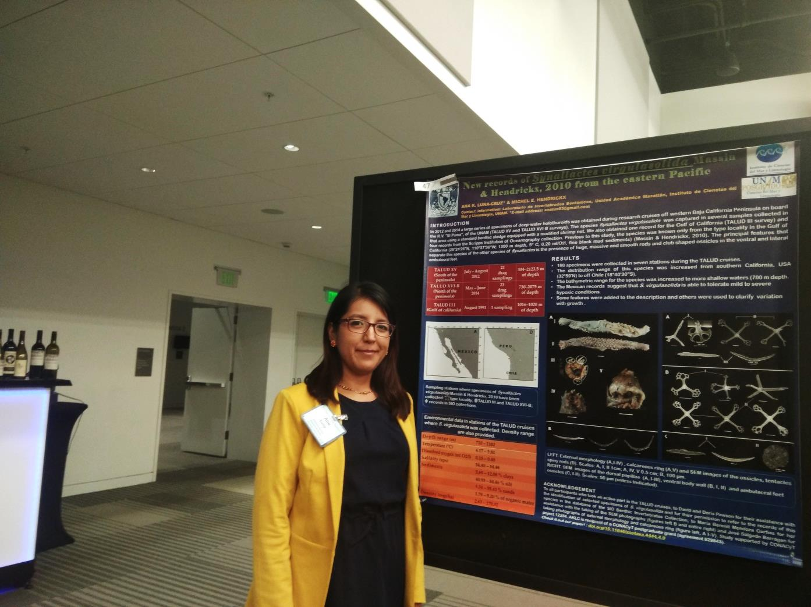
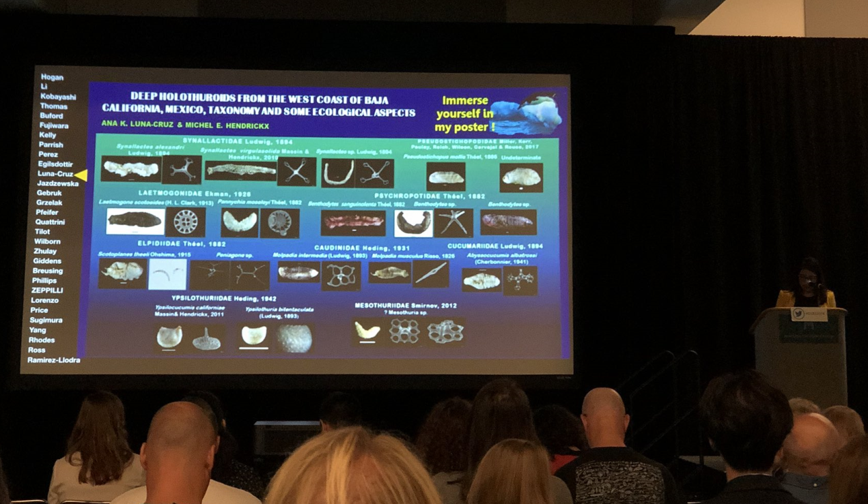
Photograph taken of: Adrian Glover. (2018 September 11th, 9:08 a.m.) Great to see @ISBAHQ @DSBSoc travel award winner Ana Luna-Cruz from Mexico with this taxonomy of deep-sea sea cucumbers @#DSBS2018 Nice spicules! [Twitter post]. Retrieved from https://twitter.com/adrg1/status/1039546251287572480
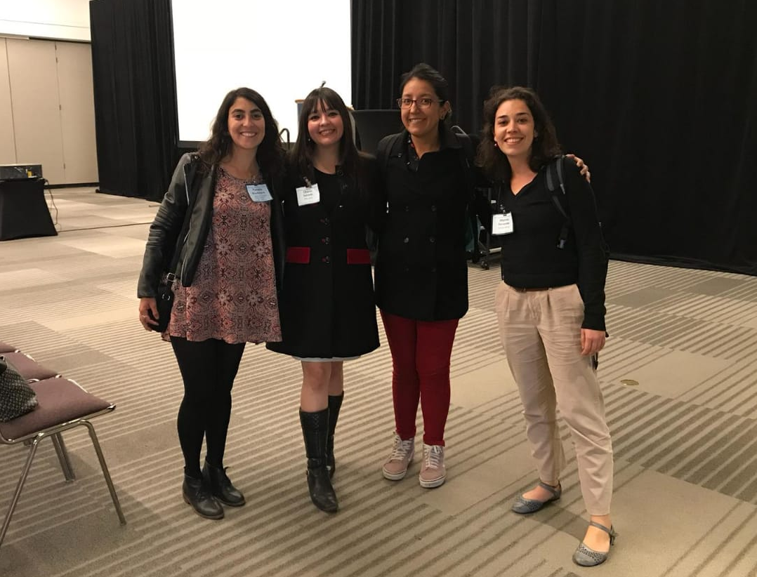
Photograph taken by Pamela Rivadeneira, with authorization to make free use of this.

