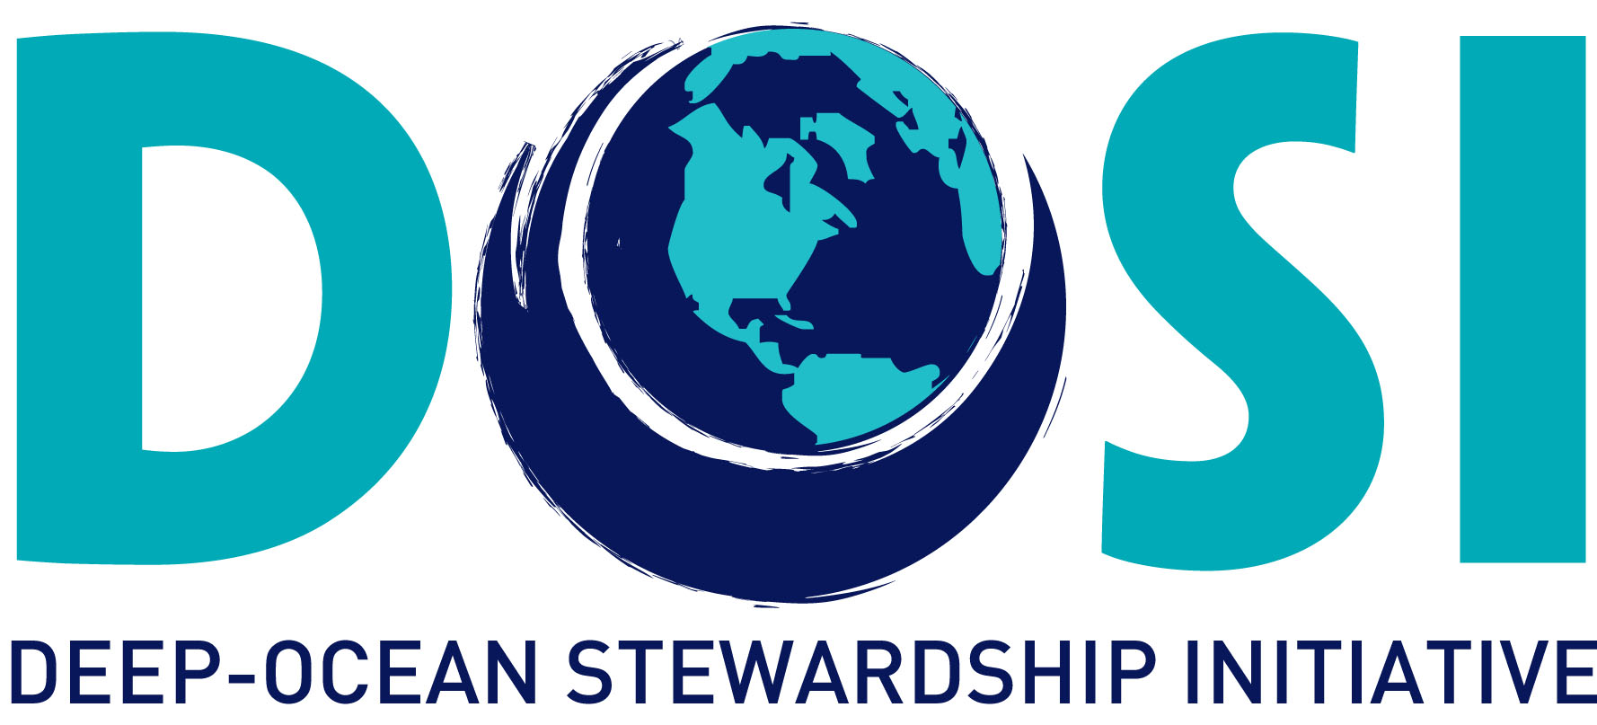

DOSI Minerals Working Group Activities 2013 to 2015

- DOSI Guidance and Recommendations
  - ISA Research Recommendation Letter (May 2014) – link to letter
  - DOSI-compiled response to ISA stakeholder survey (May 2014) – link to response
  - DOSI commentary on “Developing a Regulatory Framework for Mineral Exploitation in the Area” report to stakeholders (ISBA/Cons/2015/1). (May 2015) – link to commentary
  - DOSI-Compiled review of SPC Regulations and Recommendations – standards for scientific research and mineral exploration and exploitation and provided comments prior to publication (Oct. 2015).

- Workshops and Symposia sponsored by DOSI:
  - DOSI Inaugural Workshop (UNAM, Mexico City, MEXICO March 2013)
  - DOSI Special Session - Deep Ocean Industrialization: A New Stewardship Frontier (AAAS, Chicago, USA Feb. 2014)
  - DOSI workshop on defining significant impact & performing cumulative impact assessment (La Jolla, CA, USA March 2014)
  - DOSI Planning Workshop (Aveiro, PORTUGAL Aug. 2015)
  - DOSI observers at ISA Assembly (Kingston, JAMAICA July 2016)

- Workshops and Symposia attended by DOSI representatives:
  - IASS Potsdam Ocean Governance Workshop (GERMANY Oct 2014)
  - Deep-seabed mining & Pacific cultures symposium (Honolulu Hawaii, USA, April 2015)
  - From Seafloor Hydrothermal Systems to the Sustainable Exploitation of Massive Sulfide Deposits: Myths & Realities of the Deep Sea (Bergen, NORWAY May 2015)
  - International workshop on environmental standards for deep-sea mining (Tromso, NORWAY May 2015)
  - Towards the development of a strategic Environmental Management Plan for deep seabed mineral exploration & exploitation in the Atlantic basin (SEMPIA). (Azores, PORTUGAL June 2015)
  - Deep-Sea Tailings Placement Workshop – with IMO and GESAMP (Lima, PERU June 2015)
  - EcoDeep-SIP Workshop – The crafting of seabed mining ecosystem-based management: Assessing deep-sea ecosystems in the Pacific Ocean (Tokyo, JAPAN June-July 2015)
  - Deep Sea mining - Work with WEF and Rockefeller Foundation/RESOLVE (Bellagio, ITALY Oct. 2015)
  - Griffith Law School and the International Seabed Authority Workshop on Environmental Assessment and Management for Exploitation of Minerals in the Area (AUSTRALIA May 2016)
  - SEMPIA mini-workshop. (Azores, PORTUGAL July 2016)

- Annotated Bibliography of Key Papers, Reports & Statements. Citations of publications related to deep-sea mining are available in an open-access library for use by all stakeholders.

- DOSI Open Webinars on DSM and other issues (archive) – Link to series.

- Capacity Development
- SOPAC traineeships for two Pacific islanders: 3 months at University of Hawaii to learn techniques for conducting environmental baseline studies & biodiversity evaluation of deep-sea manganese nodule ecosystems
- DOSI leads Maria Baker & Lisa Levin co-led capacity development workshop in Namibia concerning phosphate mining impacts, co-funded by ISA.

