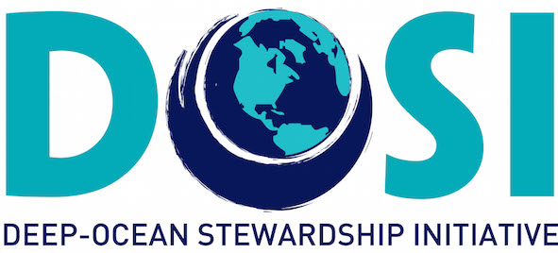

Ann Vanreusel (UGent) represented DOSI during the second day of The ISA Berlin workshop (27-29 September 2017) on the Design of Preservation Reference Zones and Impact Reference Zones in deep-sea mining contract areas. The workshop brought together representatives from ISA, its contractors, and different experts to develop a common understanding of the key elements of reference area design and monitoring principles applicable to exploitation contracts for deep-sea minerals (www.isa.org.jm/workshop/ workshop-design-impact-reference-zones-and-preservation-reference-zones-area). The first day agenda consisted of plenary talks from different representatives, introducing ISA vision and strategies, targeted system characteristics and contractors progress on the designation of IRZs and PRZs. The second day was organized in three simultaneous discussion groups that rotated among the three targeted systems for deep-sea mineral mining being massive sulphide deposits, manganese nodules and seamount carbonate crusts. In a first round of three parallel sessions, one for each system, the design for PRZs and IRZs was discussed. In the afternoon the same rotating group discussion strategy was applied to monitoring principles. Each of the rounds were introduced by one to two plenary presentations on respectively the definition and purpose of the IRZs and PRZs and monitoring insights. During the plenary presentations and discussions some time was given to clarifications on the aim and definition of the PRZs and IRZs. It was also discussed to what extent preservation reference zones needed to be modified to Control reference zone. A report on the meeting is being prepared including the recommendations that were formulated from the output of the group discussions. All presentations are available on the ISA website through the earlier indicated link.

